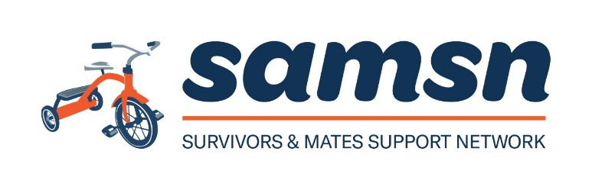

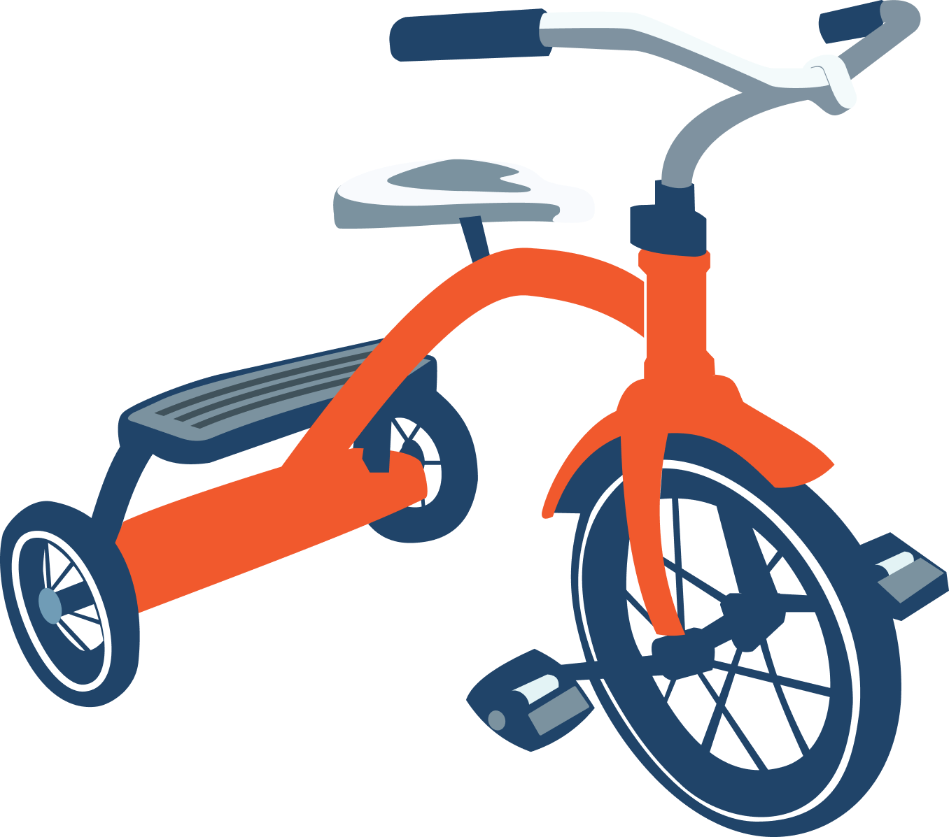Disability Inclusion Action Plan 2024-26 (DIAP)

## Contents

Contents 2

Acknowledgment of Country 4

About Us 5

Our Purpose 5

Our Vision 5

Our Values 5

What We Do 5

Our Journey 7

DIAP Methodology 7

Our DIAP Pillars 9

1. Inclusive Attitudes and Behaviours 9

2. Improving Employment Opportunities 9

3. Accessible Systems, Processes and Informational Methods 9

4. Creating Liveable Communities 9

Priorities and Actions 10

Pillar 1 – Inclusive Attitudes and Behaviours 10

Foster an inclusive, safe, and accessible environment through education and training. 10

Pillar 2 – Inclusive Employment 13

Improve recruitment methods and workplace culture to ensure that people with disability have equal access to employment and career development opportunities at SAMSN. 13

Pillar 3 – Accessible Systems, Processes & Informational Methods 16

Eliminate all barriers that prevent people with disability from easily and efficiently accessing and utilising internal and external facing systems, processes, information, and services. 16

Pillar 4 – Creating Liveable Communities 19

Increase engagement and participation of people with disability at SAMSN through enhanced accessible and inclusive practices. 19

Governance & Reporting 22

Appendices 24

Appendix A 24

Abbreviation List 24

Document Controls 25

Policy review and version tracking 25

## Acknowledgment of Country

Survivors and Mates Support Network (SAMSN) work on the land of the Dharug people. SAMSN pay deep respect to the Dharug community, their Elders past and present. We respectfully acknowledge their deep connection to land, sea, waterways and skies, and value their endless commitment to caring for Country.

Parramatta belongs to the Burramattagal clan, who first settled on the upper reaches of the Parramatta River. Burramattagal is thought to be derived from the Aboriginal word for ‘place where the eels lie down’ to breed (within the Paramatta River).

# About Us

## Our Purpose

To build a support network that gives voice and agency to male survivors and their supporters.

## Our Vision

A world in which male survivors struggling with the adverse effects of childhood sexual abuse can easily access support and find understanding and acceptance.

## Our Values

Hope The courage to believe in what’s possible

Dignity We honour each other’s inherent worth

Connection Together we achieve

Community Engaging the power of networks for growth

## What We Do

Survivors & Mates Support Network (SAMSN) was founded in 2011 by a small group of male survivors, who were searching for a support group to meet other male survivors and manage the effects of child sexual abuse on their lives. Unable to find such a group, they started SAMSN.

Walking alongside professional counsellors with experience in working with male survivors, they developed an eight-week group program for men. This professionally facilitated peer support group program provided a much-needed safe space for men and was, and is still, in great demand. These groups have provided a place for men to come together to meet other male survivors and find support, understanding and learning about child sexual abuse, its far-reaching impacts, and very importantly what helps in recovery and healing.

Since 2011 SAMSN has run over 90 groups across Sydney, some regional NSW centres, Adelaide and Canberra.

SAMSN’s growing understanding of the impacts on men, the needs of male survivors, and what helps recovery, led to SAMSN establishing ongoing, professionally facilitated monthly meetings in a number of locations so that men have a safe environment in which they can continue to have access to peer support in their recovery journey.

SAMSN has also recognised that the traumatic effects of abuse can make negotiating life’s challenges even more difficult. In 2014 SAMSN was able to employ professional staff to provide individual planned support to men and their supporters. This support includes working alongside survivors negotiating the criminal justice system or seeking redress or compensation, accessing Centrelink or housing services, or assistance finding a suitable counsellor.

The value of peer support has also been incorporated into SAMSN's work with peer support workers and planned support available to walk alongside survivors. SAMSN are proud to see the network continue to grow.

# Our Journey

SAMSN’s decision to create a DIAP was in response to the release of the findings and recommendations of the Royal Commission into Institutional Responses to Child Sexual Abuse. Specifically, Recommendation 9.3 "to improve service access for people with disability who have experienced sexual abuse in childhood, through the provision of specialist trauma-informed services, advocacy, and community development and outreach".

The Commission found that people with disability are more likely than people without disability to experience sexual assault and/or child sexual abuse, and that this cohort face significant barriers to accessing safe, appropriate and high-quality support and specialist services.

As a service provider for adult male survivors of childhood sexual abuse, SAMSN wants to improve the services, safety and supports available to people with disability. Amongst other tasks, the decision to create a DIAP was agreed upon as the most effective way forward.

# DIAP Methodology

People with Disability Australia (PWDA), a national peak not-for-profit organisation, led by and for people with disability, was engaged to undertake a robust audit and consultation process, and the subsequent scripting of SAMSN’s DIAP.

Throughout this process there was a firm commitment to ensuring that the voices of people with disability were heard and prioritised in informing the DIAP.

The audit and consultation process involved:

* 1. a desktop audit of a broad selection of internal documents comprising PDFs, Word, and PowerPoints.
* a physical access review inside the SAMSN building and immediate surrounds including transportation, accessible parking and public pathways,
* surveys and consultations with SAMSN Board, staff, volunteers, clients and a range of other key stakeholders.
* a digital content accessibility audit of sample pages across the entire SAMSN website, conducted by the Centre for Accessibility Australia.

The ensuing DIAP promotes transparency, reproducibility and consistency in dismantling attitudinal, physical, informational, and systemic barriers experienced by people with disability.

SAMSN's DIAP is based on the 1980s Social Model of Disability and the later Human Rights Model of Disability.

As per Article 1 of the United Nations Convention on the Rights of Persons with Disabilities (UNCRPD), the Social Model defines disability as: 'Long term physical, mental, intellectual or sensory impairment which, in interaction with various barriers, may hinder the full and effective participation in society on an equal basis with others'.

Australia formally committed to incorporating this Convention into its domestic laws and policies in August 2008. With this, the Social Model of Disability marked the beginning of an official paradigm shift in attitudes and approaches towards people with disability. The Social Model sees disability as the result of the interaction between people living with impairments trying to function in environments filled with physical, attitudinal, informational, and systemic barriers. It therefore carries the implication that physical, attitudinal, informational methods and systemic barriers must change to enable people living with impairments to fully participate in society on an equal basis with all others.

The emergence of the Human Rights Model of Disability in the 2000s sought to address and critique of the Social Model of Disability. While both models assert that societal change is necessary to dismantle disability barriers, the Human Rights Model additionally emphasises that all individuals, including those with a disability, are entitled to enjoyment of full human rights and dignity, and that people’s impairments must not be used as an excuse for not upholding these rights. The Human Rights Model pursues disability equity through a legal, intersectional, holistic, person-centred approach.

SAMSN’s audit and resultant DIAP commitments are further underpinned by the following prominent disability sector instruments:

* United Nations Convention on The Rights of Persons with Disabilities (UNCRPD)
* Australia’s 2021-2031 Disability Strategy
* Commonwealth Disability Discrimination Act
* NSW Disability Inclusion Act (particularly Part 2, Division 3)
* National Council of Social Services (NCOSS) NSW Disability Network Forum resource - Eliminating Discrimination and Embracing Diversity Effective Disability Inclusion Action Planning
* NSW Government Families, Communities and Disability Services; Disability Inclusion Action Planning Guidelines.

These instruments align with and inform SAMSN’s four DIAP pillars.

# Our DIAP Pillars

### Inclusive Attitudes and Behaviours

Foster an inclusive, safe, and accessible environment through education and training.

### Improving Employment Opportunities

Increase employment opportunities for, and retention of, people with disability at SAMSN.

### Accessible Systems, Processes and Informational Methods

Eliminate all barriers that prevent people with disability from easily and efficiently accessing and utilising internal and external facing systems, processes, information, and services.

### Creating Liveable Communities

Increase engagement and participation of people with disability at SAMSN through enhanced accessible and inclusive practices.

# Priorities and Actions

## Pillar 1 – Inclusive Attitudes and Behaviours

### Foster an inclusive, safe, and accessible environment through education and training.

#### Improve disability confidence of all SAMSN staff by integrating education and training into ****SAMSN’s**** suite of professional development activities.

|  |  |  |
| --- | --- | --- |
| Action | Responsibility | Timeframe |
| Introduce mandatory training with an intersectional and culturally appropriate focus on disability awareness for all staff and volunteers. | SAMSN Admin & COO | **Completed** for all existing staff as at July 2023. |
| Ensure all new staff have completed mandatory training with an intersectional and culturally appropriate focus on disability awareness within three to six months post probation. | SAMSN Admin & COO | As needed for new staff recruited from July 2024 onwards. |
| Introduce a disability confidence exercise that all staff are to complete on an annual basis. | SAMSN Admin & COO | Annually |
| Incorporate completion of disability awareness training, and any other relevant training, in Key Performance Indicators (KPI's). | SAMSN COO & People managers | By 31 October 2025 |

#### Publicly demonstrate commitment to and support for access and inclusion.

|  |  |  |
| --- | --- | --- |
| Action | Responsibility | Timeframe |
| Promote International Day of People with Disability (IDPWD) each year via communications publications (i.e., social media and newsletter) and support a local IDPWD event. | SAMSN Admin & CEO (in consultation with accessible social media consultant) | 3 December 2025 then annually |
| Minimum quarterly external communications to spotlight disability inclusion. | SAMSN Admin CEO | Once per quarter from 1 April 2025 onwards. |
| Publish DIAP on SAMSN and the AU Human Rights websites. | SAMSN Admin & Accessibility Consultant | By 31 December 2024 |

#### Internal communications to promote disability access and inclusion.

|  |  |  |
| --- | --- | --- |
| Action | Responsibility | Timeframe |
| Update image bank to reflect the diverse range of staff and service users. | Accessibility Consultant & SAMSN Admin | **Completed** 30 August 2024 |
| Once per quarter SAMSN will highlight internal and external access and inclusion success stories in public communications (e.g. SAMSN e-news, social media posts etc). | SAMSN Admin & CEO in consultation with accessible social media consultant | At least once per quarter from 1 April 2025 onwards. |

#### Increase senior management engagement and promotion of access and inclusion.

|  |  |  |
| --- | --- | --- |
| Action | Responsibility | Timeframe |
| People leaders promote DIAP in their teams and openly work towards their relevant KPI targets. | SAMSN Senior Management & people leaders. | From 1 January 2025 onwards. |
| People leaders to include data in their KPI's that indicates they are proactively improving SAMSN's inclusive culture (i.e., including participating in and encouraging DIAP and promoting workplace adjustments). | SAMSN Senior Management & people leaders. | From 1 July 2025 onwards. |
| CEO to provide messages and communications about access and inclusion, as well as support for DIAP commitments. | SAMSN CEO | From 1 April 2025 onwards, as relevant. |

## Pillar 2 – Inclusive Employment

### Improve recruitment methods and workplace culture to ensure that people with disability have equal access to employment and career development opportunities at SAMSN.

#### Create a recruitment/advertising, interview, onboarding and mentoring new staff process that is accessible and inclusive.

|  |  |  |
| --- | --- | --- |
| Action | Responsibility | Timeframe |
| Ensure applicants are aware of and encouraged to ask for reasonable adjustments for the interview process. | SAMSN Senior Management & people leaders. | From 1 January 2025 onwards |
| Ensure all staff on interview panels have completed disability confidence training, and where possible, a minimum of one staff member with disability participates in each interview panel. | SAMSN people leaders. | From 1 January 2025 onwards |
| Undertake a comprehensive examination of recruitment/advertising, interviewing, onboarding and mentoring procedures and adjust where required to increase accessibility and inclusion as per this plan. | SAMSN COO & Senior management | By 31 October 2025 |
| Implement/increase the number of touch points during the recruitment process where reasonable adjustments are offered and discussed. | SAMSN COO & Senior management | By 31 October 2025 |
| All briefs to third-party recruitment agencies specify that diverse candidates, including people with disability, are sought and assurances made that these recruitment agencies will provide reasonable adjustments to candidates should they require it. | SAMSN COO & Senior management | From 1 January 2025 onwards |

#### Support and encourage the recruitment of people with disability recruited at SAMSN.

|  |  |  |
| --- | --- | --- |
| Action | Responsibility | Timeframe |
| Investigate potential disability specific recruitment streams (i.e., engaging with hiring agencies specialising in disability recruitment). | SAMSN COO | By 31 October 2025 |
| Investigate disability affirmative action measures, specific to hiring people with disability. | SAMSN COO | By 31 October 2025 |
| Include workplace adjustment statement on SAMSN website and all position advertisements. | SAMSN COO & people leaders. | From 31 October 2025 onwards |
| Implement a workplace reasonable adjustment policy and related 'passport' template. | SAMSN COO | From 31 October 2025 onwards |

## Pillar 3 – Accessible Systems, Processes & Informational Methods

### Eliminate all barriers that prevent people with disability from easily and efficiently accessing and utilising internal and external facing systems, processes, information, and services.

#### All external and internal communications are accessible.

|  |  |  |
| --- | --- | --- |
| Action | Responsibility | Timeframe |
| Create Accessibility Guidelines outlining accessibility requirements for all materials being published (both externally and internally), including videos and pamphlets. | Accessibility Consultant | **Completed** 2 December 2024 |
| Review and align, where feasible, all internal and external communication approaches for accessibility (i.e., live captioning, interpreter, screen reader compatible, PDF or Word versions of documents, and so forth) | SAMSN senior management (in line with Accessibility Guidelines) | By 31 October 2025 |

#### All software and programs are aligned against WCAG (Web Content Accessibility Guidelines) International Standards.

|  |  |  |
| --- | --- | --- |
| Action | Responsibility | Timeframe |
| Review, align and continue to monitor all internal and external internet communication approaches against the WCAG International Standards. | SAMSN COO to manage review (in consultation with IT provider and Accessibility Guidelines).  IT to make any edits. | **Completed** June 2024.  Review annually. |

#### Ensure all internal and external meetings with staff, stakeholders and clients are accessible.

|  |  |  |
| --- | --- | --- |
| Action | Responsibility | Timeframe |
| Develop and disseminate Accessibility Guidelines for SAMSN staff to use when running accessible meetings (in person, online and hybrid). [Resources - Accessible Arts (aarts.net.au)](https://aarts.net.au/arts-resources/) | Accessibility Consultant | **Completed** 2 December 2024. |
| Ensure all meeting invitations include information identifying accessibility supports already in place for each meeting (i.e., live captioning, interpreter, screen reader compatible, PDF or Word versions of documents, and so forth), as well as notice to contact organiser for accessibility requirements not already mentioned. | SAMSN Admin (in line with Accessibility Guidelines) | From 31 October 2025 onwards |

#### Provide a client intake process that is safe, inclusive, and accessible.

|  |  |  |
| --- | --- | --- |
| Action | Responsibility | Timeframe |
| Conduct a formal accessibility-focused review of current intake process (in line with Accessibility Guidelines). | Senior Practitioner | By 31 October 2025 |
| Ensure, where possible, multiple accessible formats for all relevant documents are readily available and offered to clients during the intake processes (i.e., video with live captioning, interpreter, screen reader compatible, PDF or Word versions of documents, and so forth). | Senior Practitioner | From 31 October 2025 onwards. |

## Pillar 4 – Creating Liveable Communities

### Increase engagement and participation of people with disability at SAMSN through enhanced accessible and inclusive practices.

#### Ensure SAMSN is accessible to staff, clients, and the community.

|  |  |  |
| --- | --- | --- |
| Action | Responsibility | Timeframe |
| Prioritise all accessibility actions deemed ‘priority’; outlined in the People with Disability AU Physical Site Audit. | Accessibility Consultant & SAMSN Admin | **Completed** September 2024. |
| SAMSN should include office accessibility information on SAMSN website; including google map, route from local public transport, location of nearby accessible parking. | SAMSN Admin | By 1 April 2025. |
| SAMSN should inform all staff, clients and community members of all accessibility offered by SAMSN (informational, physical, systems/processes), then ask if they have requirements that have not been addressed. | All SAMSN staff | From 1 January 2025 onwards. |

#### SAMSN's external website is accessible for all users.

|  |  |  |
| --- | --- | --- |
| Action | Responsibility | Timeframe |
| Monitor and ensure that the SAMSN website aligns with current WCAG guidelines. | SAMSN COO to manage IT (Information and Technology). | **Completed** June 2024.  Review annually. |
| Ensure the website’s feedback, contact and complaints channels are available in accessible mediums. | SAMSN Admin & IT (in line with Accessibility Guidelines & Accessible Web Designer) | **Completed** June 2024.  Review annually. |

#### All publications are accessible and available across accessible mediums.

|  |  |  |
| --- | --- | --- |
| Action | Responsibility | Timeframe |
| Where possible, all public facing media and documents are provided in multiple accessible formats (for example, screen-reader compatible PDF or Word, Easy Read, audio, video with captioning). | SAMSN Admin (in line with Accessibility Guidelines). | From 31 October 2025 onwards. |

#### Where possible, all events held by SAMSN align with accessibility best practice.

|  |  |  |
| --- | --- | --- |
| Action | Responsibility | Timeframe |
| Develop Accessibility Guidelines on how to run an accessible event, both in person, online and hybrid.  [Resources - Accessible Arts (aarts.net.au)](https://aarts.net.au/arts-resources/) | Accessibility Consultant & SAMSN Admin | **Completed** 2 December 2024 |
| Implement multiple accessible formats for communicating information at events and seek participant feedback after all major events. | SAMSN Senior Management | From 31 October 2025 onwards. |

#### Where possible, utilise suppliers that include social enterprises that employ people with disability.

|  |  |  |
| --- | --- | --- |
| Action | Responsibility | Timeframe |
| Develop a list of suppliers that are owned and operated by people with disability, or that support people with disability. | SAMSN Admin | From 1 July 2025 onwards. |
| Track SAMSN’s spending and procurement from businesses that are owned and operated by people with disability, or support people with disability, and increase over time. | SAMSN COO | From 1 July 2025 onwards. |

# Governance & Reporting

**SAMSN has a commitment in place to monitor, review and report on the implementation progress of this DIAP.**

| **Action** | **Sub-Action** | **Responsibility** | **Timeframe** |
| --- | --- | --- | --- |
| Establish DIAP governance committee. | * Meet and review DIAP quarterly for the first year. Thereafter, meet six monthly and review DIAP annually. * Include members from each team across SAMSN. * Invite people with disability to have a seat at this table.  ('Nothing about us, without us') * Agenda for meetings to ensure assessment of DIAP implementation is being undertaken. * Ensure each action and responsibility is included in KPI's. * Seek feedback from SAMSN’s adult male survivors with disability, at minimum annually, to ensure that their guidance and perspectives are embedded into the DIAP and its implementation. | SAMSN Senior Management. | From 1 April 2025 onwards. |
| Ensure accountability to DIAP commitments. | * Publish DIAP on SAMSN website. * Lodge a copy of DIAP with The Australian Human Rights Commission [Register of Disability Discrimination Act Action Plans | Australian Human Rights Commission](https://humanrights.gov.au/our-work/disability-rights/register-disability-discrimination-act-action-plans) | Accessibility Consultant & SAMSN Admin | By 31 December 2024 |
| Reporting of DIAP commitments and achievements. | * Annual reporting to SAMSN CEO, Board, PAC, and broader community in accessible formats including SAMSN website, on the progress of DIAP. * In annual reports, include data on SAMSN’s engagement of men with disability across their services, as well as qualitative feedback about changes to SAMSN’s programs because of the DIAP implementation. | SAMSN COO | From 1 July 2025 onwards. |

# Appendices

## Appendix A

### Abbreviation List

Throughout this document, the following acronyms and initialisms are used:

ADN - Australian Disability Network

CEO - Chief Executive Officer

DIAP - Disability Inclusion Action Plan

HR - Human Resources

IDPWD - International Day of People with Disability

IT - Information and Technology

KPI - Key Performance Indicator

NDS - National Disability Strategy

NSW - New South Wales

SAMSN - Survivors and Mates Support Network

UNCRPD - United Nations Convention on the Rights of Persons with Disabilities

WCAG - Web Content Accessibility Guidelines

WHS - Work, Health and Safety

## Document Controls

|  |  |
| --- | --- |
| **Document Controls** | **Description** |
| **Document name** | SAMSN Disability Inclusion Action Plan 2024 |
| **Document number** | 2.0 |
| **Document owner** | SAMSN COO |
| **Frequency of review** | 12 Months |
| **Approved** | All SAMSN staff |
| **Date approved** | 06/12/2024 |
| **Endorsed** | SAMSN CEO |
| **Status** | Complete |
| **Point of contact** | SAMSN COO |
| **Stakeholder distribution** | All SAMSN Staff |
| **Policy Context (Legislation or other requirements)** | * United Nations Convention on The Rights of Persons with Disabilities (UNCRPD) * Australia’s 2021-2031 Disability Strategy * Commonwealth Disability Discrimination Act * NSW Disability Inclusion Act (Part 2, Division 3) * NSW Government Families, Communities and Disability Services; Disability Inclusion Action Planning Guidelines. |

|  |  |  |
| --- | --- | --- |
| **Distribution** | **Responsibility** | **Date** |
| **All SAMSN Staff** | Karise McNamee | **25/11/2024** |

### Policy review and version tracking

|  |  |  |  |  |
| --- | --- | --- | --- | --- |
| **Version** | **Author** | **Approved by** | **Date** | **Next review due** |
| **1.0** | People With Disability Australia (PWDA) & Karise McNamee (in consultation with SAMSN Senior Management) | SAMSN CEO & COO | 17/06/2024 | **01/07/2025** |
| **2.0** | Karise McNamee | SAMSN CEO | 06/12/2024 | **06/12/2025** |